Engineering Chemistry
Assignment No. 1

Q. 1 What are the salient features of VSEPR theory?
Discuss the geometry of the following using VSEPR theory: (a) H₃O⁺ and (b) SF₄.
The Valence Shell Electron Pair Repulsion (VSEPR) theory is a model used to predict the three-dimensional shapes of molecules based on minimizing the repulsion between electron pairs in the valence shell of an atom. The key salient features of the VSEPR theory include:
- Electron Pair Repulsion:
- The central idea of VSEPR theory is that electron pairs, whether bonding or non-bonding, repel each other. The geometry of a molecule is determined by the arrangement that minimizes the repulsion between these electron pairs.
- Basic Assumption:
  - The VSEPR theory assumes that electron pairs (both bonding and non-bonding) around a central atom will arrange themselves in space to minimize repulsion and achieve the most stable configuration.
- Types of Electron Pairs:
  - VSEPR considers two types of electron pairs: bonding pairs (resulting from covalent bonds) and non-bonding pairs (also called lone pairs, which are not involved in bonding).
- Geometric Arrangements:
  - The VSEPR theory predicts the geometric arrangement of atoms around a central atom based on the number of bonding and lone pairs. The common molecular geometries include linear, trigonal planar, tetrahedral, trigonal bipyramidal, and octahedral.
- Steric Number:
  - The steric number of an atom is the sum of the number of bonded atoms and the number of lone pairs around the central atom. It is used to determine the molecular geometry.
- Bond Angles:
  - The VSEPR theory provides information about the bond angles between atoms in a molecule, which are influenced by the repulsion between electron pairs. For example, a molecule with four electron pairs (tetrahedral geometry) will have bond angles of approximately 109.5 degrees.
- Lone Pair Influence:
  - Lone pairs generally exert stronger repulsion than bonding pairs. As a result, the presence of lone pairs can distort the predicted bond angles and molecular geometry.
- Multiple Bonds:
  - VSEPR theory is applicable not only to single bonds but also to multiple bonds. However, multiple bonds are treated as a region of high electron density.
- Polar vs. Nonpolar Molecules:
  - VSEPR theory allows predictions regarding the overall polarity of a molecule based on the individual bond polarities and molecular geometry.
- Applicability:
  - VSEPR theory is particularly useful for predicting the shapes of simple molecules and ions with a central atom surrounded by other atoms or lone pairs.
In summary, the VSEPR theory provides a simple and effective approach for predicting the shapes of molecules by considering the repulsion between electron pairs and achieving the most stable arrangement in three-dimensional space.
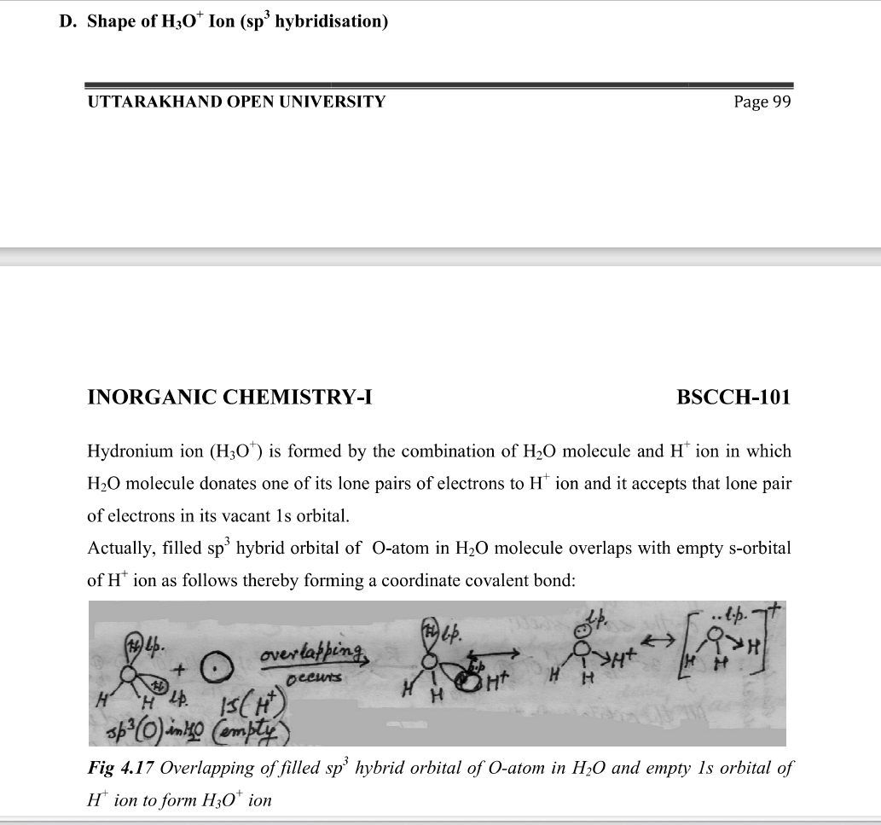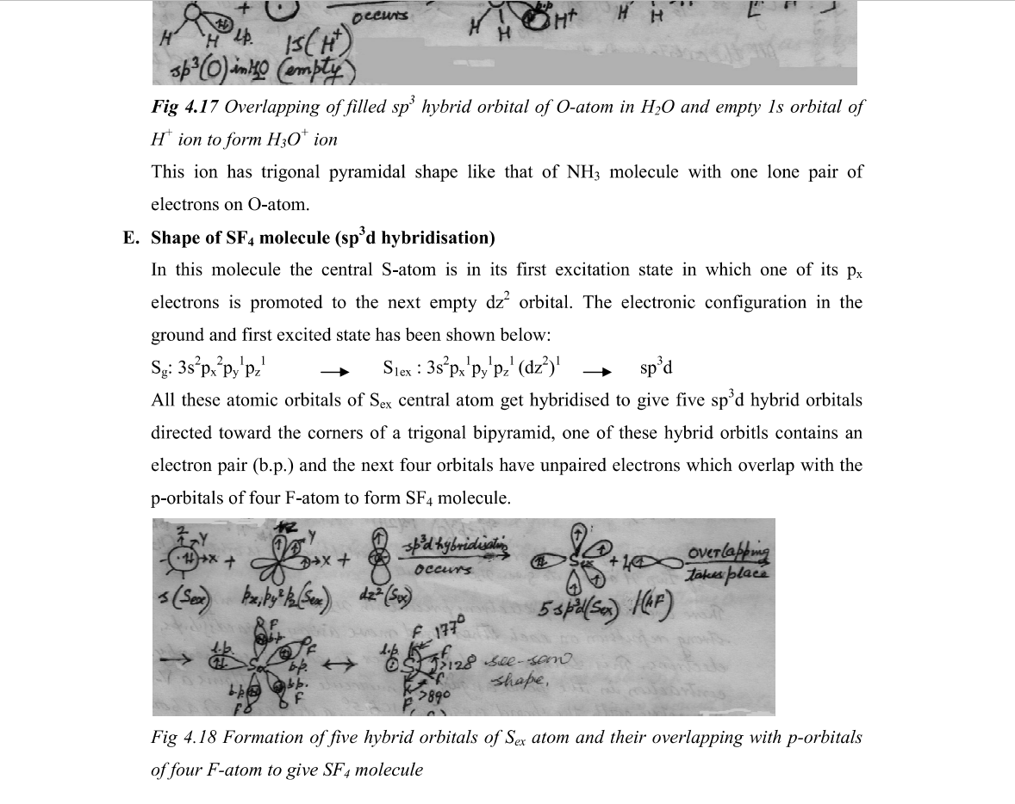

Q.2 Write the general outer electronic configuration of s, p, d and f block elements. Explain the general properties of elements belonging to these groups.

Q.3 Predict the atomic and ionic radii of atoms in periodic table by giving proper explanation.
Ans: The atomic and ionic radii of atoms in the periodic table generally follow certain trends, which can be explained by the underlying principles of atomic structure and the periodic law. Atomic and ionic radii are measures of the size of an atom or ion.
- Atomic Radii:
  - As you move across a period from left to right, the atomic radius generally decreases. This is due to an increase in the effective nuclear charge (the positive charge felt by the outer electrons), which attracts the electrons closer to the nucleus.
  - As you move down a group, the atomic radius generally increases. This is because electrons occupy higher energy levels as you move down, leading to larger orbits and greater distances from the nucleus.
- Ionic Radii:
  - Cations (positively charged ions): When an atom loses one or more electrons to form a cation, the outer electron shell is now closer to the nucleus, making the cation smaller than its parent atom. This is especially evident for elements on the left side of the periodic table.
  - Anions (negatively charged ions): When an atom gains one or more electrons to form an anion, the outer electron shell experiences increased electron-electron repulsion, causing the anion to be larger than its parent atom. This is particularly noticeable for elements on the right side of the periodic table.
- Exceptions:
  - Transition metals and inner transition metals can exhibit variations in atomic and ionic radii due to their unique electron configurations and the presence of partially filled d or f orbitals. Additionally, factors such as electron-electron repulsion and shielding effects can influence these trends.
In summary, understanding the periodic trends in atomic and ionic radii involves considering the effective nuclear charge, electron-electron repulsion, and the electron configuration of the elements. The trends provide valuable insights into the behavior of atoms and ions across the periodic table.

Q.4 What do you understand of electronegativity? Write its application.
Ans Electronegativity: Electronegativity is a measure of the tendency of an atom to attract a bonding pair of electrons in a chemical bond. It is a property that helps to predict the nature of the chemical bonds formed between different elements. The concept of electronegativity was first proposed by Linus Pauling.
Key Points:
- Trend Across Periods and Down Groups:
  - Electronegativity generally increases across a period from left to right on the periodic table. This is because, as you move across a period, the effective nuclear charge increases, making atoms more attractive to electrons.
  - Electronegativity generally decreases down a group. This is because, as you move down a group, the outer electrons are farther from the nucleus, and the increasing number of electron shells reduces the effective nuclear charge.
- Application of Electronegativity:
  - Determination of Bond Type:
    - When the electronegativity difference between two atoms is small (typically less than 0.5), the bond is considered nonpolar covalent, meaning the electrons are shared equally.
    - When the electronegativity difference is moderate (around 0.5 to 1.7), the bond is considered polar covalent, indicating an unequal sharing of electrons.
    - A large electronegativity difference (usually greater than 1.7) suggests an ionic bond, where one atom transfers electrons to another.
  - Chemical Reactivity:
    - Highly electronegative elements often have a greater tendency to attract electrons during chemical reactions, influencing the reactivity of compounds involving these elements.
  - Prediction of Molecular Polarity:
    - The concept of electronegativity is used to determine the polarity of molecules. If a molecule has polar bonds and is asymmetrical in shape, it is likely to be a polar molecule.
  - Biochemical and Biological Processes:
    - Electronegativity plays a role in understanding the behavior of elements in biological systems, such as enzyme-substrate interactions and the structure of biomolecules.
  - Solubility and Intermolecular Forces:
    - Electronegativity differences can affect the strength of intermolecular forces between molecules, influencing properties like solubility, boiling points, and melting points.
  - Prediction of Acid-Base Behavior:
    - Electronegativity differences between elements can indicate their tendency to donate or accept electrons in acid-base reactions.
Understanding electronegativity is crucial for predicting and explaining the behavior of elements in various chemical and physical contexts, aiding in the interpretation of molecular properties and reactivity.

Q. 5 Discuss about the polarization power in periodicity.
Ans Polarization power, also known as polarizability, is a property of atoms and ions that describes their ability to undergo distortion of electron distribution in response to an external electric field. This phenomenon is particularly significant for larger and more diffuse atoms or ions. The concept of polarization power is closely related to the size and electronic structure of atoms and ions.
  - Across Periods: moving from left to right across a period in the periodic table, the polarization power generally decreases. This is because the effective nuclear charge increases, reducing their ability to respond to an external electric field.
  - Down Groups: moving down a group, the polarization power generally increases. This is because atoms or ions become larger, Larger and more diffuse electron clouds are more easily polarized.
- Relation to Atomic Size:
  - Larger atoms or ions, which have more electron shells and greater electron cloud dispersion, tend to have higher polarization power
- Applications:
  - Ionic Bonding: In ionic compounds, cations and anions with higher polarizability tend to form more easily. Larger anions are more polarizable, which contributes to the stability of ionic compounds.
  - Chemical Reactivity: The polarization of atoms or ions can affect their reactivity. For example, in transition metal chemistry, the ability of metal ions to distort their electron cloud can influence their ability to catalyze certain reactions.
  - Properties of Materials: Polarization power is relevant to the properties of materials, including dielectric materials. Materials with higher polarizability may have unique electrical and optical properties.
- Exceptions and Special Cases:
  - Polarization power is influenced not only by size but also by factors such as electron configuration, shielding effects, and the presence of partially filled d or f orbitals. Transition metals and inner transition metals can exhibit variations in polarization power.

Q.6 Write a note on
a) Bonding and Antibonding Molecular orbital
ans Molecular orbitals are formed by the combination of atomic orbitals during the process of molecular orbital theory. There are two main types of molecular orbitals: bonding molecular orbitals and antibonding molecular orbitals.
- Bonding Molecular Orbitals (BMO):
  - Bonding molecular orbitals result from the in-phase overlap of atomic orbitals. When atomic orbitals combine constructively, the resulting molecular orbital has a lower energy than the original atomic orbitals.
  - Electrons in bonding molecular orbitals contribute to the stability of a molecule because they spend more time between the nuclei, where the attractive forces are stronger.
  - The sigma (σ) and pi (π) bonds in organic chemistry are examples of bonding molecular orbitals.
- Antibonding Molecular Orbitals (ABMO):
  - Antibonding molecular orbitals result from the out-of-phase overlap of atomic orbitals. When atomic orbitals combine destructively, the resulting molecular orbital has higher energy than the original atomic orbitals.
  - Electrons in antibonding molecular orbitals contribute to the destabilization of a molecule because they spend more time away from the region between the nuclei, where the attractive forces are weaker.
  - Antibonding orbitals are often denoted by adding an asterisk () to the symbol of the corresponding bonding orbital. For example, a sigma bonding orbital is denoted as σ, and its antibonding counterpart is denoted as σ.

b) Effective nuclear charge
ans Effective nuclear charge (Zeff) is a concept in atomic physics and chemistry that represents the net positive charge experienced by an electron in a multi-electron atom. It takes into account the shielding effect of inner electrons, which reduces the attraction of the outer electrons to the nucleus.
The effective nuclear charge can be calculated using the formula:
�eff=�−�Zeff​=Z−S
Where:
- �Z is the atomic number, representing the total number of protons in the nucleus.
- �S is the shielding constant, representing the screening or shielding effect of inner electrons.
Key Points:
- Shielding Effect:
  - Inner electrons (closer to the nucleus) shield the outer electrons from the full attractive force of the nucleus. The more inner electron shells there are, the greater the shielding effect.
- Periodic Trend:
  - Across a period (from left to right in the periodic table), the effective nuclear charge generally increases. This is because electrons are added to the same energy level, resulting in minimal additional shielding, while the number of protons in the nucleus increases.
- Group Trend:
  - Down a group (from top to bottom in the periodic table), the effective nuclear charge remains relatively constant or slightly decreases. This is due to the addition of electron shells, which increases the distance between outer electrons and the nucleus, leading to increased shielding.
- Impact on Atomic Properties:
  - The effective nuclear charge influences various atomic properties, such as atomic size, ionization energy, and electron affinity.
  - Greater effective nuclear charge generally leads to a smaller atomic size and higher ionization energy. This is because electrons are held more tightly by the stronger attraction from the nucleus.
- Calculation in Multi-electron Atoms:
  - For multi-electron atoms, the effective nuclear charge is an average value that considers the distribution and shielding effects of all the electrons in the atom.
Understanding effective nuclear charge is crucial for explaining trends in atomic properties across the periodic table and predicting the behavior of electrons in atoms. It provides insights into the factors that influence the arrangement and behavior of electrons in different elements.

c) Electron Gain enthalpy
ans Electron gain enthalpy (also known as electron affinity) is the amount of energy released or absorbed when an atom gains an electron to form a negative ion. It is an important property of elements and is denoted by the symbol Δ�egΔHeg​ or Δ�eaΔHea​. The process of gaining an electron can be represented by the equation:
�(�)+�−→�−(�)X(g)+e−→X−(g)
Key Points:
- Sign Convention:
  - If the process of gaining an electron is exothermic (energy is released), the electron gain enthalpy is negative.
  - If the process is endothermic (energy is absorbed), the electron gain enthalpy is positive.
- Factors Influencing Electron Gain Enthalpy:
  - Atomic Size: Smaller atoms generally have more negative electron gain enthalpies. This is because the added electron is closer to the nucleus, experiencing a stronger attractive force.
  - Effective Nuclear Charge: Higher effective nuclear charge contributes to a more negative electron gain enthalpy, as the added electron is more strongly attracted to the nucleus.
  - Electron Configuration: Elements with electron configurations that result in a stable, filled electron shell upon gaining an electron are more likely to have a more negative electron gain enthalpy.
- Trends in the Periodic Table:
  - Across a period (from left to right), electron gain enthalpy generally becomes more negative. This is because the effective nuclear charge increases, leading to a stronger attraction for an additional electron.
  - Down a group (from top to bottom), electron gain enthalpy tends to become less negative or even positive. This is because the added electron is entering a higher energy level, farther from the nucleus, and the shielding effect of inner electron shells reduces the effective attraction.
- Exceptions:
  - There are some exceptions to the general trend. For example, elements in Group 2 (alkaline earth metals) have positive electron gain enthalpies despite being on the right side of the periodic table. This is because adding an electron to these elements would result in a less stable electron configuration.
- Applications:
  - Understanding electron gain enthalpy is important in predicting the reactivity of elements, particularly in the formation of negative ions.
  - It is relevant in the study of electron transfer processes in chemical reactions.
In summary, electron gain enthalpy provides insights into the energy changes associated with the addition of an electron to an atom, influencing the chemical behavior and reactivity of elements.

Q.7 Write the electronic configuration, energy level diagram, calculate the bond order and predict the magnetic behavior of : N₂, N₂²⁺, N₂⁺, N₂⁻, N₂²⁻.
Ans Let's determine the electronic configuration, energy level diagram, calculate the bond order, and predict the magnetic behavior for the given species: �2N2​, �22+N22+​, �2+N2+​, �2−N2−​, �22−N22−​.
1. �2N2​ (Nitrogen Molecule):
- Electronic Configuration: 1�22�22�31s22s22p3
- Energy Level Diagram:
Copy code
1s ↑↓ 2s ↑↓ 2p ↑ ↑ ↑
- Bond Order (BO): ��=12(�b−�a)BO=21​(Nb​−Na​) ��=12(8−5)=32BO=21​(8−5)=23​
- Magnetic Behavior: Paramagnetic (due to the presence of unpaired electrons)
2. �22+N22+​ (Dicationic Nitrogen Molecule):
- Electronic Configuration: 1�22�22�11s22s22p1
- Energy Level Diagram:
Copy code
1s ↑↓ 2s ↑↓ 2p ↑ ↑
- Bond Order (BO): ��=12(�b−�a)BO=21​(Nb​−Na​) ��=12(7−5)=1BO=21​(7−5)=1
- Magnetic Behavior: Diamagnetic (all electrons are paired)
3. �2+N2+​ (Cationic Nitrogen Molecule):
- Electronic Configuration: 1�22�12�31s22s12p3
- Energy Level Diagram:
Copy code
1s ↑↓ 2s ↑ 2p ↑ ↑ ↑
- Bond Order (BO): ��=12(�b−�a)BO=21​(Nb​−Na​) ��=12(8−5)=32BO=21​(8−5)=23​
- Magnetic Behavior: Paramagnetic (due to the presence of unpaired electrons)
4. �2−N2−​ (Anionic Nitrogen Molecule):
- Electronic Configuration: 1�22�22�41s22s22p4
- Energy Level Diagram:
Copy code
1s ↑↓ 2s ↑↓ 2p ↑ ↑ ↑ ↑
- Bond Order (BO): ��=12(�b−�a)BO=21​(Nb​−Na​) ��=12(10−5)=2.5BO=21​(10−5)=2.5
- Magnetic Behavior: Paramagnetic (due to the presence of unpaired electrons)
5. �22−N22−​ (Dianionic Nitrogen Molecule):
- Electronic Configuration: 1�22�22�51s22s22p5
- Energy Level Diagram:
Copy code
1s ↑↓ 2s ↑↓ 2p ↑ ↑ ↑ ↑ ↑
- Bond Order (BO): ��=12(�b−�a)BO=21​(Nb​−Na​) ��=12(12−5)=3.5BO=21​(12−5)=3.5
- Magnetic Behavior: Paramagnetic (due to the presence of unpaired electrons)
In summary:
- Species with unpaired electrons (e.g., �2N2​, �2+N2+​, �2−N2−​, �22−N22−​) are paramagnetic.
- Species with all electrons paired (e.g., �22+N22+​) are diamagnetic.
- The bond order increases with the addition of electrons to the bonding molecular orbitals.

Q.8 Why He₂ molecule not exist and He₂⁺ molecule exist.
Ans 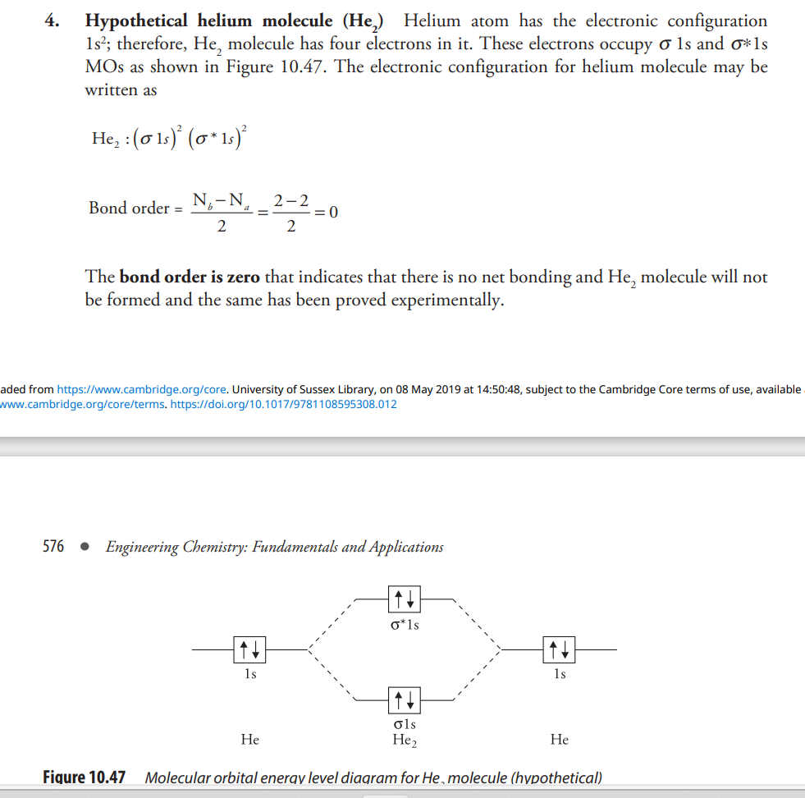 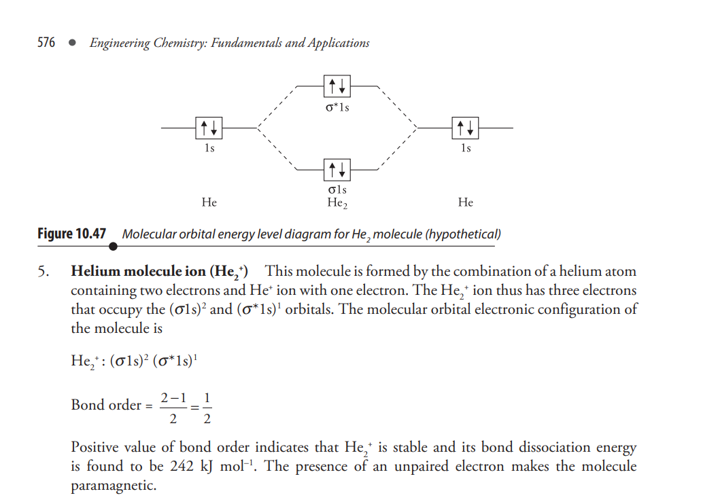
Q.9 Draw energy level diagram of CO molecule, calculate its bond order.
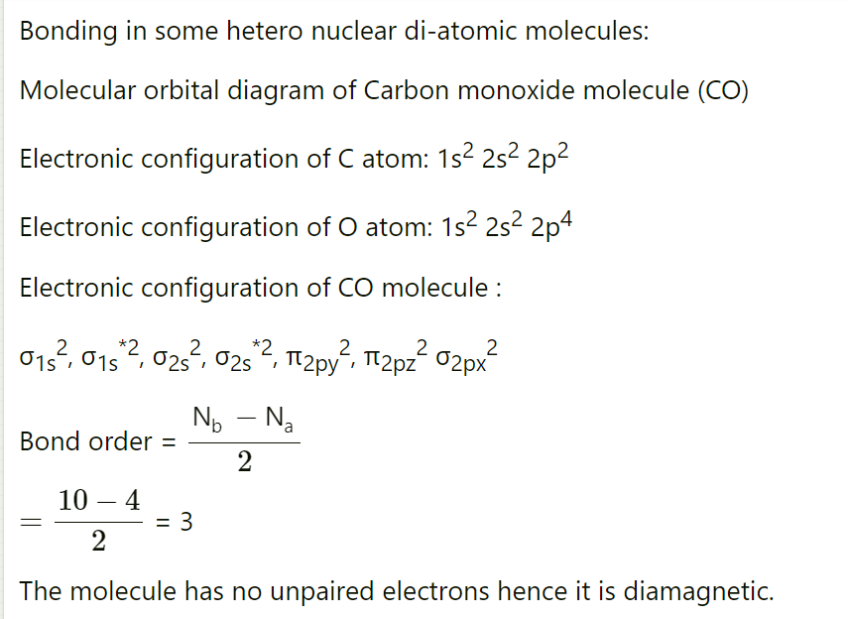
Q.10 Write postulates of MOT and CFT

Mot: Molecular Orbital Theory In 1932, Hund and Mulliken had put forward the molecular orbital theory. The main features of this theory are as follows (i) New orbitals termed as the molecular orbitals are formed by the overlap of atomic orbitals of the combining atoms. The atomic orbitals lose their individual identity after the formation of the molecular orbitals. (ii) The number of molecular orbitals formed is equal to the number of atomic orbitals involved in their formation. (iii) The electron in an atomic orbital is influenced by just one positive nucleus of the atom, that is, it is monocentric, whereas depending upon the number of atoms in the molecule the electron of a molecular orbital is under the influence of more than one nuclei, that is, it is polycentric. (iv) Similar to the atomic orbitals, the filling of electrons in the molecular orbitals also follows the Aufbau principle, Hunds rule of maximum multiplicity and Pauli’s exclusion principle. (v) Atomic orbitals with comparable energies as well as proper orientations combine to form molecular orbitals.
Molecular Orbital Theory (MOT):
Molecular Orbital Theory is a model for predicting the behavior of electrons in molecules. Here are the postulates of the Molecular Orbital Theory:
- Atomic Orbitals Combine to Form Molecular Orbitals:
  - Atomic orbitals (AOs) of the participating atoms combine to form molecular orbitals (MOs) that belong to the entire molecule.
- Linear Combination of Atomic Orbitals (LCAO):
  - Molecular orbitals are formed by a linear combination of atomic orbitals, meaning that AOs are added or subtracted with appropriate phase adjustments to create MOs.
- Number of Molecular Orbitals Equals the Number of Atomic Orbitals:
  - The number of molecular orbitals formed is equal to the number of atomic orbitals that combine.
- Molecular Orbitals are Filled with Electrons:
  - Electrons fill the molecular orbitals following the same rules as for atomic orbitals, such as the Pauli exclusion principle and Hund's rule.
- Energy Levels of Molecular Orbitals:
  - Molecular orbitals are assigned energy levels, and electrons fill these orbitals from the lowest to the highest energy level, following the aufbau principle.
- Bonding and Antibonding Molecular Orbitals:
  - The combination of atomic orbitals results in the formation of both bonding and antibonding molecular orbitals. Bonding orbitals lower the energy of the molecule, while antibonding orbitals raise it.
- Bond Order:
  - Bond order is calculated as 12(�b−�a)21​(Nb​−Na​), where �bNb​ is the number of electrons in bonding orbitals and �aNa​ is the number of electrons in antibonding orbitals.
Crystal Field Theory (CFT):
Crystal Field Theory is a model used to describe the electronic structure and properties of transition metal complexes. Here are the postulates of the Crystal Field Theory:
- Electrostatic Interactions:
  - The theory considers the electrostatic interactions between metal ions and ligands in a complex.
- Metal d-Orbitals Splitting:
  - The metal d-orbitals, which are degenerate (have the same energy) in a free metal ion, split into different energy levels when ligands approach the metal ion.
- Octahedral and Tetrahedral Complexes:
  - In octahedral complexes, the d-orbitals split into two sets: three lower-energy orbitals (t2g) and two higher-energy orbitals (eg). In tetrahedral complexes, the splitting involves the lower-energy set (t2) and the higher-energy set (e).
- Ligands Influence Splitting:
  - The extent of splitting (crystal field splitting) depends on the nature and strength of the ligands. Strong ligands cause larger splitting compared to weak ligands.
- High Spin and Low Spin Configurations:
  - The filling of d-orbitals depends on the energy difference between the sets. If the energy required to pair electrons in the higher energy orbitals is less than the energy required to place electrons in the lower energy orbitals, a high spin configuration is favored.
- Color of Transition Metal Complexes:
  - The color of transition metal complexes arises from electronic transitions between the split d-orbitals. The energy of absorbed light corresponds to the energy difference between these levels.
These postulates help to explain and predict the magnetic, optical, and structural properties of transition metal complexes.

